Create Your Own FTP Youth Event
Sample Schedule
8:15 AM Buffet breakfast
Use existing groups or assign small groups or have students choose individually which video rooms to have on their rotation.
8:45 AM Move into Large Group space
Session 1 Welcome
Opening Prayer
Show Sean McDowell video (47 min)
Small groups meet around the large group space & work through discussion questions
(discussion questions provided in Youth Leaders & Teachers drop down menu)

9:45-10:00 AM As discussion wraps up, allow time for restroom break
Session 2 Students move into 1 of the smaller meeting rooms to view video from 1 of the drop-down menu categories

10:30 AM Rotate into the 3rd video and discussion room
Session 3

11:00 AM Students move into another small group video & discussion room
Session 4

11:30 AM Physical activity
Hike, outside game, gym time

noon Lunch & enjoying time socializing

12:30 PM Large Group Space
Session 5 Closing Prayer
Final Video & Discussion
Hand out FTP stickers & website cards for students to keep &/or share

Needs:
Large group space with internet and projection capabilities
3 smaller group spaces with internet and projection capabilities
3+ Discussion leaders that stay in the small group spaces even as groups rotate who are comfortable with tech and leading discussion with provided questions.
Food preparers, servers, & cleanup crew
Signage/schedule/map: What videos & what rooms

Some of the flexibilities:
Great for Believers and Seekers- so it’s a great “Bring a Friend” opportunity!
Youth led or Adult led or Hybrid
Youth Event or Intergenerational Event
Add music
Set groups or changing groups depending on which videos the attendees want to watch
2 meals or 1 meal
Choose videos of most interest to your students

Video Recommendations:
Opening session
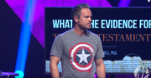
Sean McDowell on defending the Bible
www.youtube.com/watch?v=o-qdUD0kDug
​(46 min- but well worth it!)​
Momentum Youth Conference 2019

Rotation video rooms:
History Room
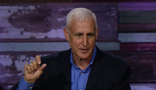
The Unintentional Eyewitness Support of the Gospels
Video: youtu.be/NPoQIVi4T1k (6 min 14 sec)
You may have heard somebody claim the following: “You can’t trust the Bible because Jesus was a man who was a great teacher but still no more than a man, and besides, in the decades after his death, his followers invented Christianity by embellishing his words and actions to turn him into this mythical God-man figure.”
It may sound sophisticated and smart, but the reality, as NBC “Dateline” cold-case detective J. Warner Wallace explains in the following video, the Gospels are solid and credible testimony that you could stake your life on in court.

Science Room
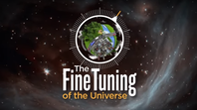
​The Fine-Tuning of the Universe as Evidence of God
https://youtu.be/UpIiIaC4kRA (6min27sec)
The very structure of the universe is determined by the fundamental constants and quantities discovered by brilliant minds.

Prophecy Fulfilled Room
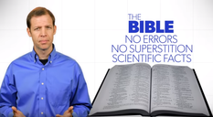
Six Amazing Scientific Facts In The Bible
www.youtube.com/watch?v=EvOWr83qYk0 (12min17sec)
The Bible has been accused of being an outdated book of superstition, written by people who didn’t understand the scientific workings of the real world. This statement is false. Not only does the Bible contain no errors and no superstitious ideas, it contains scientific facts that were written down thousands of years before we in modern scientific times understood how important they were. Kyle Butt presents a lesson on six scientific facts that validate the Bible.

Closing Session
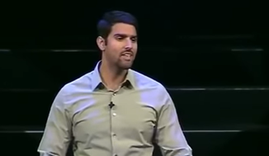
Nabeel Qureshi - Seeking Allah, Finding Jesus
www.youtube.com/watch?v=i3j9pCPzbqA (50 min)
Raised as a devout Muslim in the United States, Nabeel grew up studying Islamic apologetics with his family and engaging Christians in religious discussions. After one such discussion with a Christian, the two became friends and began a years-long debate on the historical claims of Christianity and Islam. Nabeel chronicled his resulting journey in his first book, Seeking Allah, Finding Jesus. In this video Nabeel shares some of his personal experiences through that journey. It is excellent and well worth the time.

